Online streaming refers to the continuous, real-time transmission of audio and video content over the internet from a remote server directly to a user’s device. Unlike traditional digital downloads, which require a file to be completely saved before playback, streaming delivers data in small, continuous packets so media can play almost instantly without using permanent storage space.
Online Streaming
Andile Mapfumo

Contents
Task Definition 2
What is the current situation? 2
What will be the focus and purpose (desired outcome) of my Investigation? 2
How will I go about the investigation considering all the PAT requirements? 2
Who is the information for (target audience)? 4
Focus Question: How Has Online Streaming Taken Oven The Modern Era Of Entertainment 5
Appendices 6
Research Questions 6
Folder Structure 12
Findings 13
Questionnaire 13
Spreadsheet 14
Database 15

No table of figures entries found.

Task Definition

What is the current situation?

Online Streaming has taken the world by storm. Being popularised in the early days of COVID-19, many people see it as a form of entertainment above all else. If you don’t know what online streaming is, in simple terms online streaming is a technology that allows you to watch a video or listen to music over the internet without you having to download the entire file first. There are two types of streaming, which is On-Demand Streaming, which is content stored on a server, and is accessible at any time with internet access. The second type is Live Streaming, which is content that is broadcasted on the internet in-real time as the event happens.

What will be the focus and purpose (desired outcome) of my Investigation?

The purpose of this investigation is to do broad research and find out more about Online Streaming, get more information about On-Demand Streaming and Live-Streaming and what forms of entertainment Online Streaming provides. I will also do research on how online streaming affects the general user, the positive and negative impacts and how users actually use it in their daily lives.

How will I go about the investigation considering all the PAT requirements?

The way I will be going through in terms of conducting this Investigation is as follows:
- This investigation is going to be separated into three phases.
- Phase 1: Research document consisting of all research conducted on this topic and sources.
- Phase 2: Questionnaire made for the public to answer questions with regards to how they feel about this topic, Database used to review and go through the answers in the questionnaire, Spreadsheet and updated research document.
- Phase 3: Website (HTML) to communicate the answers to my questions and my main findings to the required target audience and Final Research document
- There are going to be 10 questions that I am going to base this whole investigation on which are going to guide me to the completion of this investigation
- I am going to browse the internet and look for answers to these questions and acknowledge the sources I have used to answer the questions using the appropriate referencing style in my bibliography
- A questionnaire is going to be created and it is going to be based on the topic of this investigation and how the public feels about it. The questions are going to be catagorised to keep the quality of the questionnaire and simplify the data collection
- The data will be collected and analysed to find the answers needed to complete the investigation
- A spreadsheet based on all the answers from the questionnaire will be made
- The research document will be updated with the summary of the answers captured from the questionnaire
- A website will be created and the purpose of it is to display the findings of the investigation to the appropriate target audience that will find the information in this investigation useful.
- Lastly the final document finalizing the whole investigation will be made

Who is the information for (target audience)?

The target audience of this investigation will be to all the people that will find this investigation of use to them. This could be broadly useful to people that use Online Streaming on a daily basis and interested to know more about it. The other target audience would be people that rely on Online Streaming as a business model or a stream of income and want to gain more information about it to improve how they use streaming services.

Focus Question: How Has Online Streaming Taken Oven The Modern Era Of Entertainment

Appendices

Research Questions

No. | Category | Question | Question (1,2,3,4) | Type of Source | Summary of information
1 | Background | What is Online Streaming | 1 | Website | What is streaming? Streaming refers to any media content – live or recorded – delivered to computers and mobile devices via the internet and played back in real time. Podcasts, webcasts, movies, TV shows and music videos are common forms of streaming content
2 | Problem | What are the Pros and Cons of Online Streaming | 2 | Newspaper Article | PROS:  - Most streaming apps let you choose what you want to watch or listen to freely, meaning that you don't have to abide by a cable or radio schedule.  CONS:  - You constantly require internet connection
3 | Recommendation | How has Online Streaming proven different to how entertainment was consumed before | 4 | Blog | Online Streaming uses internet instead of traditional cable network and consumers have to subscribe to their desired streaming service. Traditional entertainment services such as cable TV and radio have declined due to the convenience and usability of online streaming
4 | Evaluate | How do streaming platforms use AI to protect intellectual property and prevent illegal restreams of live events | 3 | Website | NSFW recognition technology is specifically tailored to identify explicit or sensitive content. By training AI models on vast datasets, these systems can detect nudity, violence or other inappropriate visuals in a matter of milliseconds, helping to prevent the spread of harmful material.
5 | Evaluate | How does Online Streaming work | 3 | Website | Just like other data that's sent over the Internet, audio and video data is broken down into data packets. Each packet contains a small piece of the file, and an audio or video player in the browser on the client device takes the flow of data packets and interprets them as video or audio.
6 | Recommendation | How will the integration of Virtual Reality into mainstream streaming platforms change the bandwidth requirements for the average household? | 4 | Blog | So let’s say you’re streaming a high-definition 360-degree video in VR. To create a sense of presence and detail, the video needs to be high resolution (often 4K or even 8K) and delivered at a high frame rate to avoid motion sickness. This translates to a massive stream of data that needs to be constantly delivered to your headset. According to some studies, a high-quality, immersive VR experience can require sustained bandwidth of 100 Mbps or even higher, significantly more than what’s typically needed for standard HD video streaming.  Interactive VR, where your movements and actions in the virtual world are reflected in real-time, adds even more data as your position and interactions need to be constantly transmitted and received.
7 | Problem | What digital safety measures can parents implement to restrict age-inappropriate content on shared streaming accounts | 2 | Website | Set parental controls across platforms and devices. Parental controls can help block and filter content to prevent exposure to inappropriate material.  Cross-device parental controls include:  - Apple’s Screen Time (available with iOS)  - Google Family Link (available across devices and apps)  - Microsoft Family Safety (available across Microsoft devices, including Xbox, tablets, phones and laptops
8 | Problem | What are the legal consequences for individuals who “pirate” streaming boxes or illegal streaming services in South Africa | 2 | Blog | In South Africa, the punishment for viewing illegal streaming services is a fine of R5,000 or three years in jail for first-time offenders and R10,000 or five years for repeat offenders, according to the Copyright Act.  However, South Africans can be tried in terms of different legislation.  Anti-piracy director at MultiChoice-owned Irdeto, Frikkie Jonker, says individuals who consume pirated content could face a fine, up to 10 years in jail, or both.
9 | Background | Differentiate between the different types of Online Streaming | 1 | Website | SVOD: Subscription Video On Demand which is a subscription based service which allows consumers to pay a rate per month for a catalog of content.  Live Streaming: It is the ability to watch video while it is happening real-time.  Music Streaming: A service in which consumers listen to music online using internet access
10 | Recommendation | How has the rise of “Subscription Fatigue” in 2026 influenced the way South African consumers choose between paid services and Free-Ad Streaming TV platforms | 4 | Report | Subscription Fatigue has risen in South Africa due to many consumers being overwhelmed with how many subscriptions they have to keep up with. Therefore majority of the South Africans either opt for the cheapest subscription or they use free services that contain ads. Some even use pirate websites.

Author(s)/Organisation(s)/Publisher | Myles Illidge
Name of website or webpage | MyBroadband
Date Created/Updated | 03 October 2024
Date Accessed | 15 February 2026
URL | https://mybroadband.co.za/news/broadcasting/563207-piracy-crackdown-in-south-africa-up-to-10-years-jail-time-for-viewers.html

Authority | MyBroadband is a reputable information source also their various Social Media platforms are provided
Currency | The webpage was created two years ago, therefore the information is still quite relevant
Accuracy | Compared with: https://intensefibre.co.za/2025/05/28/warning-to-south-africans-using-pirate-streaming-apps/
Objectivity | This site provided unbiased information
Coverage | This site covers the piracy concept that illegal online streaming sites partake in and the consequences that go with piracy

(Illidge, 2024; Illidge, 2024)

Author(s)/Organisation(s)/Publisher | Ernesto Escobar
Name of website or webpage | Medium
Date Created/Updated | May 13 2020
Date Accessed | 15 February 2026
URL | https://medium.com/digital-media-society-spring-2020/the-impact-that-streaming-sites-have-on-society-ef45c37f2efe

Authority | Medium is a reputable source as it is verified by a commercial entity
Currency | The information may be outdated as it was published six years ago
Accuracy | Compared with: https://digitalagencynetwork.com/the-impact-of-streaming-services-on-the-entertainment-industry/
Objectivity | This site provided unbiased information that has statistics
Coverage | This site covered the impacts online streaming has on society

(Escobar, 2020)

Author | Dave Johnson
Title of Source | The beginner's guide to streaming, including how it works, the pros and cons, and more
Date Created | January 12 2021
Date Accessed | 15 February 2026
Publisher | Business Insider

Authority | Business Insider is a commercial entity that is known around the world
Currency | The information may be a bit outdated as it was published five years ago
Accuracy | Compared with: https://www.jou.ufl.edu/insights/dilemmas-live-streaming/
Objectivity | This article provided opinionated and biased information
Coverage | This Article covered the pros and cons of Online streaming in detail

(Johnson, 2021)

Folder Structure

Findings

Questionnaire

A questionnaire was drafted and distributed to 28 anonymous people. The purpose of the questionnaire was to gather some information about how people use the different types of Online streaming platforms that they pay a subscription fee for and how satisfied they are with using them. A series of questions were asked in a checkbox format and their biographical information were strictly not asked.
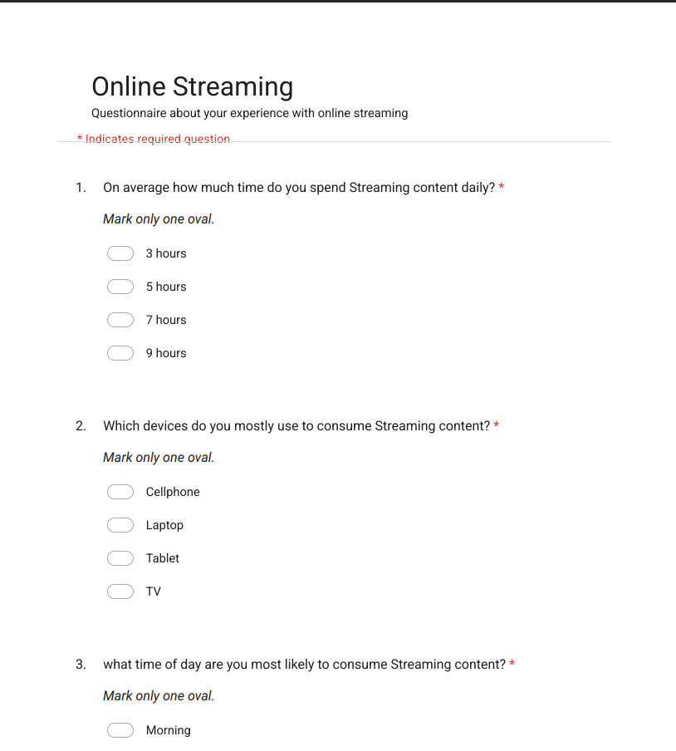
..\Questionnaire\Questionnaire Questions\Online Streaming.PDF: For a preview of the full questionnaire

Spreadsheet

After the questionnaire was distributed, 28 responses came back and the findings were processed in an Excel Spreadsheet titled “Online Streaming (responses)” Some of the responses were formatted using conditional formatting to make it easier to interpret the data and the data was interpreted visually using pie charts and bar graphs.

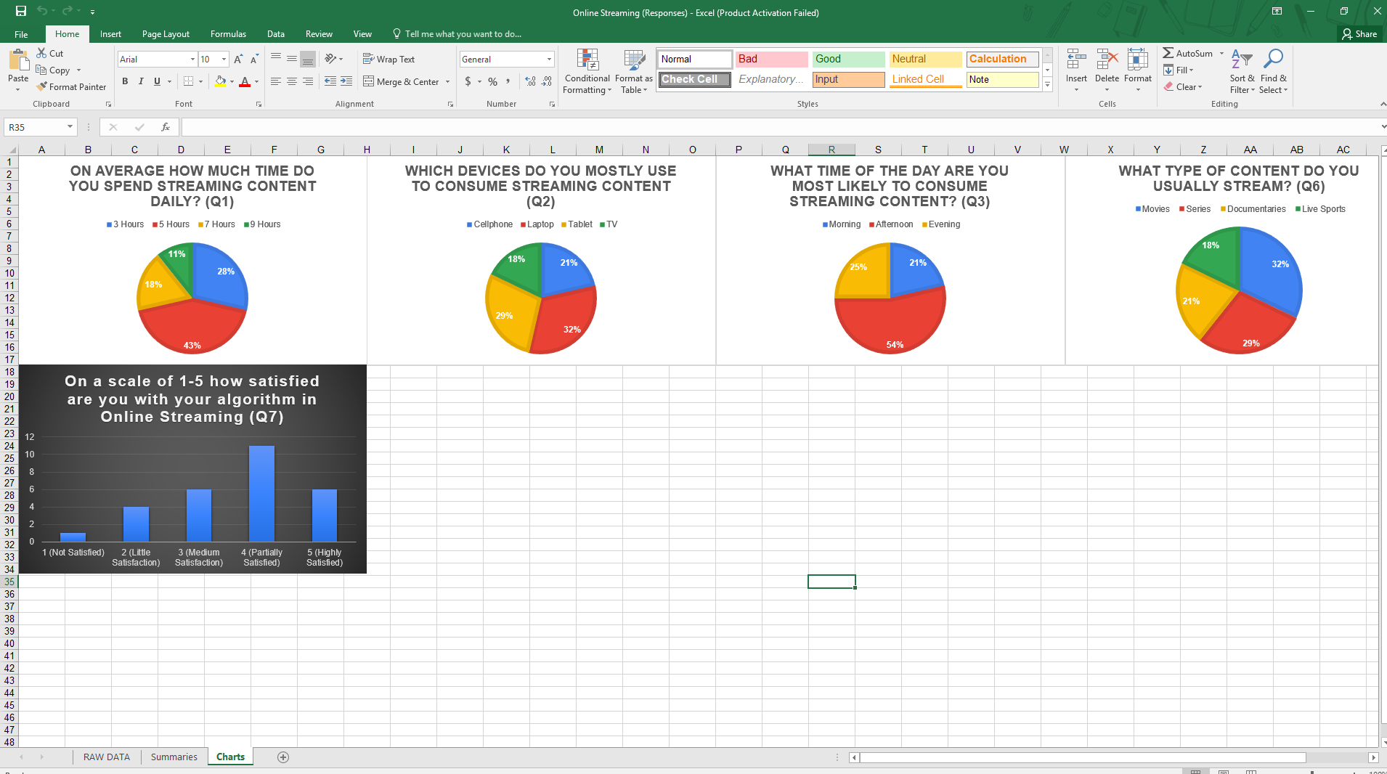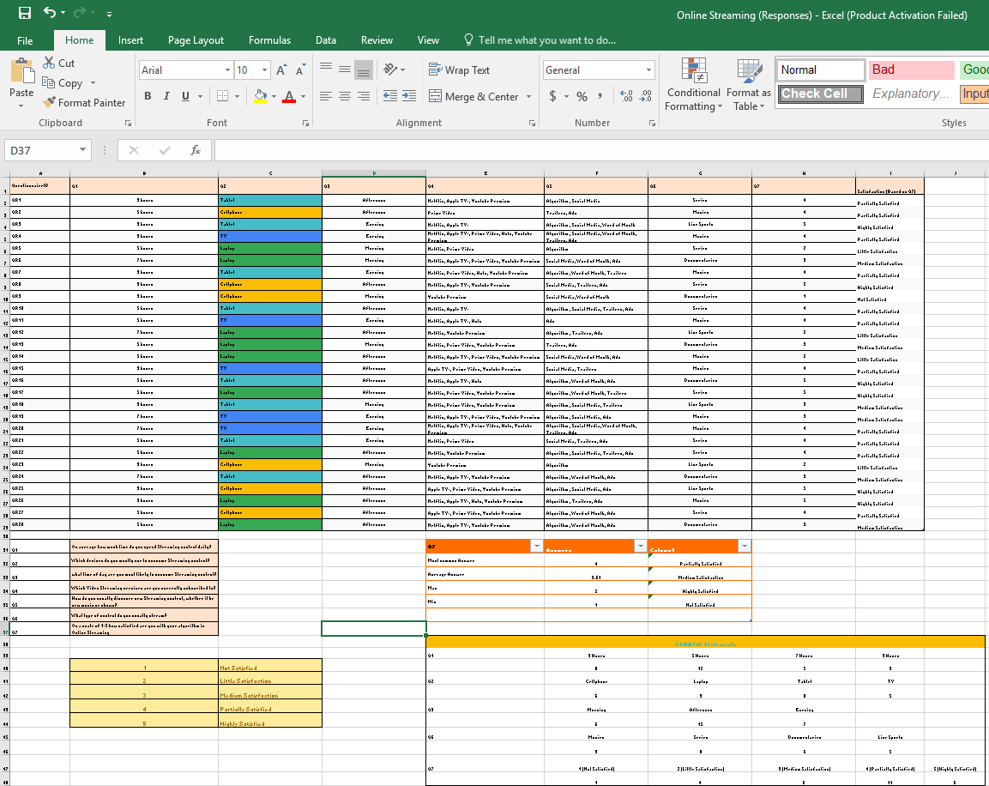

..\Spreadsheet\Online Streaming (Responses).xlsx: For the full Excel Spreadsheet

Database

After the Responses data was processed in the Excel Spreadsheet, the information was then transferred into a Database. First a table called “Form Responses ” based on the form responses transferred from the spreadsheet was created, then three queries called “qry 1: People Using Streaming Services in the Afternoon”, ” qry 2: People That use Online Streaming on their Laptops” and “qry 3: Hours and Content Type Query”. A report named “rpt: Q2” was further created as a database link to organize all the information from the spreadsheet.

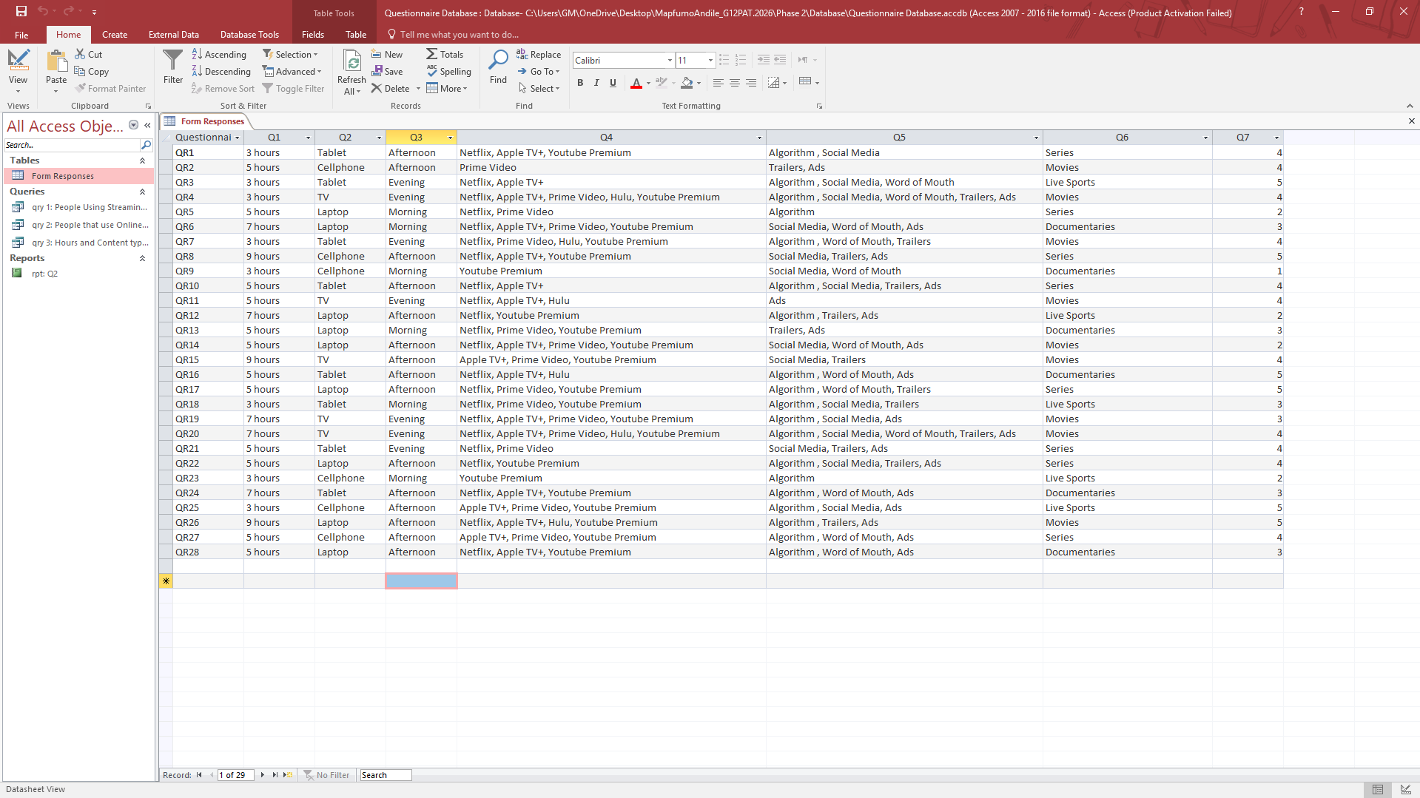

..\Database\Questionnaire Database.accdb: To review the full Database

